Dashboard Layout
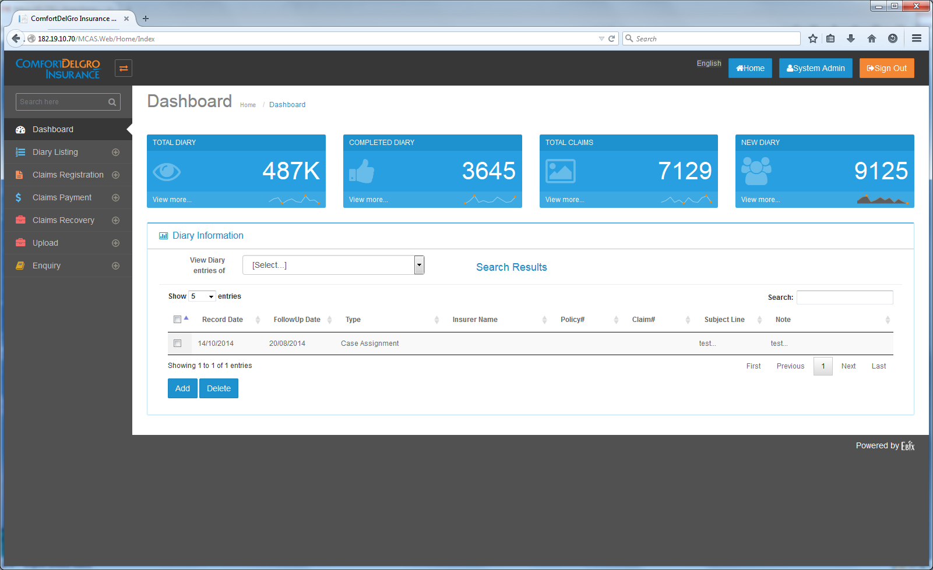
Changes Required:
- To display Five Sections: Tasks, Diary, Reassigned Diary, Escalation Diary, Mandate Approval (for Supervisor Group), Payment Approval (for Supervisor Group only)
Is user able to change the type of data to be displayed in display sections? i.e. Task section change into Payment made for the month.

Can user track the following so as to assist them in meeting their KPI
- Monthly no. of TPPD/TPBI claims settled
- Monthly amount paid for TPPD/TPBI Claims, including amount in payment requests pending approval,
- Monthly amount recovered for Recovery Claims
- Or any other type of indicators to assist them in meeting their KPI.

- To display Highlighted Colors for each entries - yellow/green when it is 3 days before Action Due Date and Red when the current date is past the Action Due date
- To have sorting for each Column
- The possibility for users to rearrange the five sections by moving the section up or down
- To have five blue boxes to provide overview of the number of items – have options to display e.g. Total Number, Number of Tasks due in 30 Days?
Is the number of different displayed sections at any one time in the dashboard capped at 5? If the number of different sections is not capped at 5, what is the maximum number of different sections allowable?
Column Headers:
Tasks:
S/No. | Claim No. | Claimant Name | Action Due | Close Date | Modified Date | Prompt Details | Action
 |  |  |  |  |  |  | << Select >>
Note: Clicking Select will bring user to the Task Screen of the particular Claim No.

Diary:
S/No. | Claim No. | Claimant Name | Diary Description | Created By | Estimated Completion Date | Action
 |  |  |  |  |  | << Select >>

Reassigned Diary:
S/No. | Claim No. | Claimant Name | Diary Description | Created By | Previous CO In-Charge | Estimated Completion Date | Reassigned By | Action
 |  |  |  |  |  |  |  | << Select >>

Escalation Diary:
S/No. | Claim No. | Claimant Name | Diary Description | Created By | Estimated Completion Date | Action
 |  |  |  |  |  | << Select >>

Mandate Approval:
S/No. | Claim No. | Claimant Name | Claim Type | Mandate Request Date | Total Mandate Amount Requested | Action
 |  |  |  |  |  | << Select >>

Payment Approval:
S/No. | Claim No. | Claimant Name | Claim Type | Payment Request Date | Total Payment Amount Requested | Action
 |  |  |  |  |  | << Select >>

